**3. MOCKITO EXERCISES**

**EXERCISE 1: MOCKING AND STUBBING**

public interface ExternalApi {

String getData();

}

**Service class**

public class MyService {

private ExternalApi api;

public MyService(ExternalApi api) {

this.api = api;

}

public String fetchData() {

return api.getData();

}

}

**Test class**

import org.junit.jupiter.api.Test;

import static org.junit.jupiter.api.Assertions.assertEquals;

import static org.mockito.Mockito.*;

public class MyServiceTest {

@Test

public void testExternalApi() {

ExternalApi mockApi = mock(ExternalApi.class);

when(mockApi.getData()).thenReturn("Mock Data");

MyService service = new MyService(mockApi);

String result = service.fetchData();

assertEquals("Mock Data", result);

}

}

**OUTPUT:**

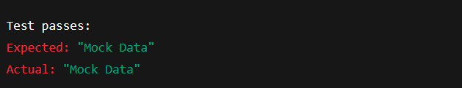

**EXERCISE 2: VERIFYING INTERACTIONS**

public interface ExternalApi {

String getData();

}

**Service class**

public class MyService {

private ExternalApi api;

public MyService(ExternalApi api) {

this.api = api;

}

public String fetchData() {

return api.getData();

}

}

**Test class**

import org.junit.jupiter.api.Test;

import static org.mockito.Mockito.*;

public class MyServiceTest {

@Test

public void testVerifyInteraction() {

ExternalApi mockApi = mock(ExternalApi.class);

MyService service = new MyService(mockApi);

service.fetchData();

verify(mockApi).getData();

}

}

**OUTPUT:**

